

Assignment

On

Artificial Intelligence Theory (2)

Course Title: Artificial Intelligence

Course Code: CSE 417

Submitted To:

Richard Philips

Lecturer Dept. of Computer Science Engineering

Submitted By:

Most. Saher Banu

Id# 143372002

Program: B.CSE

Batch: 37th

Submission Date: 10.03.2019
Table of Contents:

1. Missionaries and Cannibals Problem.

1.1: Initial State……………………………………………...1

1.2: Successor Function………………………………….2

1.2.1: Breadth Fast Search…........................3

1.2.2: Depth Fast Search…………………………..4

1.3: Goal State…………………………………………………5

1.4: Diagram of a State Space…………………………..6

2. Man, Women and Two child Problem:

2.1: Initial State……………………………………………...7

2.2: Successor Function………………………………….8

2.2.1: Breadth Fast Search…........................9

2.2.2: Depth Fast Search…………………………..10

2.3: Goal State…………………………………………………11

2.4: Diagram of a State Space…………………………..12

3. Lion, Lamb and Grass Problem:

3.1: Initial State……………………………………………...13

3.2: Successor Function………………………………….14

3.2.1: Breadth Fast Search…........................15

3.2.2: Depth Fast Search…………………………..16

3.3: Goal State………………………………………………17

3.4: Diagram of a State Space………………………..18
Missionaries and Cannibals Problem

Initial State:

A missionaries and cannibals problem state would be

(3M, 3C, B, 0M, 0C)

Successor Function:

The successor function of missionaries and cannibals problem which is solved Breadth First Search(BFS) and Depth First Search(DFS).

Breadth First Search:

Missionaries | Cannibals | Via | Pos | Missionaries | Cannibal
3M | 3C | B | L | 0M | 0C
3M | 1C | B | R | 0M | 2C
3M | 2C | B | L | 0M | 1C
3M | 0C | B | R | 0M | 2C
3M | 1C | B | L | 0M | 2C
1M | 1C | B | R | 2M | 2C
2M | 2C | B | L | 1M | 1C
0M | 2C | B | R | 3M | 1C
0M | 3C | B | L | 3M | 0C
0M | 1C | B | R | 3M | 2C
0M | 2C | B | L | 3M | 1C
0M | 0C | B | R | 3M | 3C

Depth First Search:

Solution using depth First Search is giving an optimal solution:

Missionaries | Cannibals | Via | Pos | Missionaries | Cannibal
3M | 3C | B | L | 0M | 0C
2M | 2C | B | R | 1M | 1C
3M | 2C | B | L | 0M | 2C
3M | 0C | B | R | 0M | 3C
3M | 1C | B | L | 0M | 2C
1M | 1C | B | R | 2M | 2C
2M | 2C | B | L | 1M | 1C
0M | 2C | B | R | 3M | 1C
0M | 3C | B | L | 3M | 0C
0M | 1C | B | R | 3M | 2C
1M | 1C | B | L | 2M | 2C
0M | 0C | B | R | 3M | 3C

Goal State:

The goal state is:

(0M, 0C, B, 3M, 3C)

Diagram of the state Space:
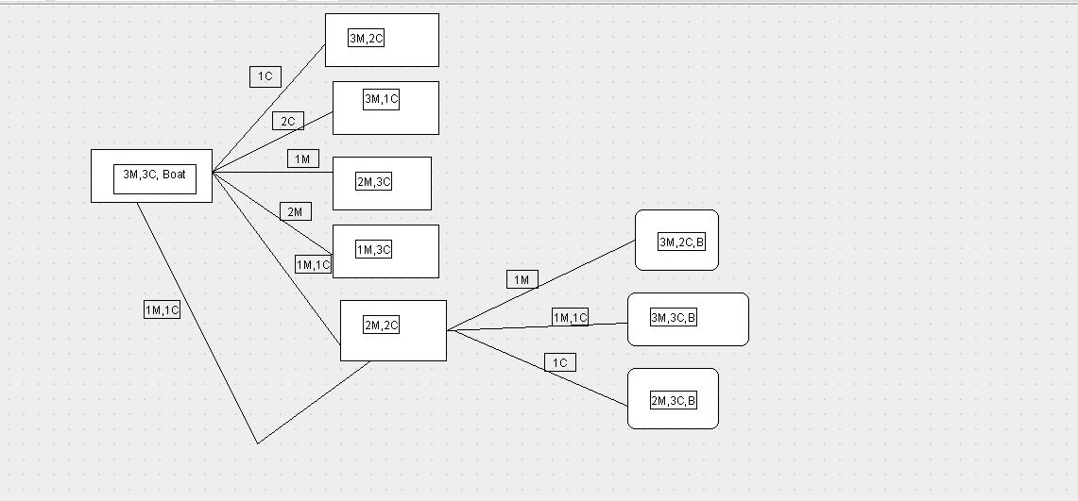
Man, woman and Two Child problem

Initial State:

At initial state, the condition approaches:

(1M, 1W, 2c , B, 0M, 0W, 0C).

Successor Function:

The successor function of this state solved by BFS and DFS:

Breadth First Search :

Man | Women | Child | Via | Pos | Man | Women | Child
1M | 1W | 2C | B | L | 0M | 0W | 0C
1M | 0W | 2C | B | R | 0M | 1W | 0C
1M | 0W | 0C | B | L | 0M | 1W | 2C
0M | 1W | 0C | B | R | 1M | 0W | 2C
0M | 0W | 0C | B | L | 1M | 1W | 2C
Depth First Search:
1M | 1W | 2C | B | L | 0M | 0W | 0C
1M | 1W0 | 0C | B | R | 0M | 0W | 2C
1M | 0W | 0C | B | L | 0M | 1W | 2C
0M | 0W | 2C | B | R | 1M | 1W | 0C
0M | 0W | 0C | B | L | 1M | 1W | 2C

Goal State: At goal state, the final condition approaches:

(0, 0 , 0, B, 1M, 1W,2C).

Diagram of a state space:
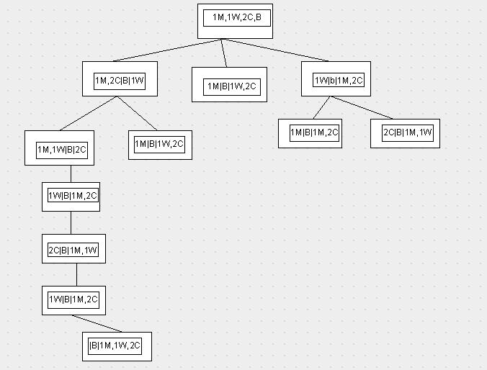
Lion , Lamb and Grass Problem

Initial State:

At initial state , the condition of lion, lamb and grass position is:

(Li, La, G, B, 0, 0, 0).

Successor Function:

Successor function is being solved using BFS and DFS.

Breadth First Search:

Lion | Lamb | Grass | Via | Pos | Lion | Lamb | Grass
Li | La | G | B | L | 0 | 0 | 0
Li | 0 | G | B | R | 0 | 1 | 0
0 | La | G | B | L | 1 | 0 | 0
0 | La | 0 | B | R | 1 | 0 | 1
0 | 0 | 0 | B | L | 1 | 1 | 1

Depth First Search:

Lion | Lamb | Grass | Via | Pos | Lion | Lamb | Grass
Li | La | G | B | L | 0 | 0 | 0
0 | La | G | B | R | 1 | 0 | 0
0 | La | 0 | B | L | 1 | 0 | 1
Li | 0 | 0 | B | R | 0 | 1 | 1
0 | 0 | 0 | B | L | 1 | 1 | 1

Goal State:

At goal State, the condition approaches:

(0, 0, 0, B, Li,La,G).

Diagram of a state space:

The state space diagram of Lion, Lamb and Grass problem is given below:
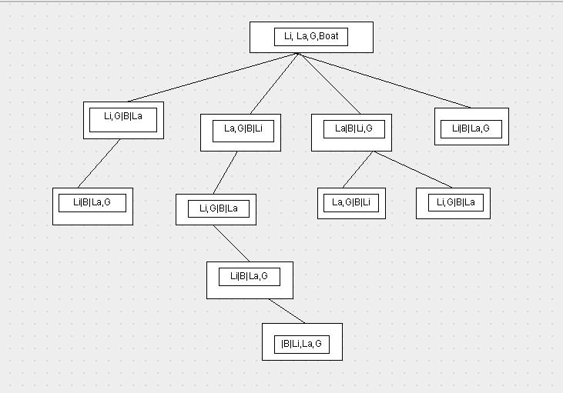

References:

http://courses.cs.washington.edu/courses/cse415/14sp/assignments/hw1/hw1.html

https://www.cse.unsw.edu.au/~cs3411/16s1/tut/sol/wk03sol.html

http://facweb.cti.depaul.edu./mobasher/classes/HON207/Homework/a3-sol.pdf

